Prospectus 2019-20
Sharing educational excellence for everyone

VERSION 4.5/ DEC2019

Contents

Page 3 | Foreword
Page 4 | Introduction and Aims
Page 5 | Reasons for joining the AAT
Page 6 | Ethos and culture
Page 7 | Vision and strategy
Page 8 | Performance, challenge and support
Page 10 | Governance and leadership
Page 11 | Organisation
Page 13 | Members
Page 15 | Trustees
Page 19 | Business operation
Page 20 | Central Team  Our additional professionals
Page 21 | Process for academisation and joining the Alban Academies Trust

The Alban Academies Trust is set up to serve primary and secondary schools in and near St. Albans with the aim of building a learning community to share educational excellence for everyone. All members of the trust are valued and able to make a powerful contribution to the on-going progress of improvement across the AAT.
It is important to us that all members of the trust hold the same broad views on the values associated with outstanding provision for all. The cross-phase nature of the trust is critical to supporting a holistic approach to education, enabling professionals from all phases to share ideas and work together to raise standards.
A key aspect of our vision is for each school to maintain its own distinctive character and to cherish heritage whilst at the same time seek opportunities to further strengthen culture and ethos across the AAT.
The Alban Academies Trust membership is developing as follows:
Sandringham School, St Albans September 2017 Ridgeway Academy, Welwyn Garden City September 2018 Verulam School, St Albans September 2018
Wheatfields Junior School Spring 2020 Wheatfields Infants’ and Nursery School Spring 2020 Garden Fields JMI School September 2020

This is an exciting opportunity to show how collaborative working can shape and define improvement and provide amazing opportunities for the young people in our care.
If this approach is appealing, we would love to hear from you.

Lin Keen Chair of Trust
The AAT Board

This prospectus sets out the philosophy and framework for the AAT cross-phase multi-academy trust in Hertfordshire.

Multi-academy trusts involve a group of like-minded schools working together to improve the educational outcomes for all children within the Trust.

The Alban Academies Trust (AAT) was established on 1st August 2017 to provide schools in and near St. Albans with a local high-quality cross-phase trust designed to respond to the needs of each member school, offering individual autonomy alongside the strength and security of collective partnership. We seek to secure the
rapid and sustained improvement of every school in the AAT through promoting high-quality leadership as a result of working together.

Maintained schools (and existing single academy trusts) who are seriously considering joining a multi- academy trust as the next phase in their development, have the opportunity to join with us and contribute to the strategic direction of the AAT.

Each school will have its own starting position however we believe the following are some of the benefits of working within our Multi-Academy Trust arrangement:
- Providing a co-ordinated 3 to 19 educational experience
- Ability to retain individual heritage and vision whilst benefitting from working in partnership
- Sharing and developing excellent practice in teaching and learning
- Opportunity to develop the learning environment through shared capital projects
- Improved qualities of leadership to support the strengthening school performance
- Access to wider curriculum opportunities for children, and improved capacity to provide extended services across the AAT
- Enhanced opportunities for CPD and ability to share resources and workload
- Help to safeguard long term financial future through economies of scale and recruitment and retention of staff
- Development of governance at local and system level by working alongside other governors
- Opportunity to shape the vision and direction of the AAT as it grows in the future
The AAT also has strong links with the Alban Federation (Awarding body for Initial Teacher Training), the Alban Teaching School Alliance (for staff development) and the Research School Hub. AAT schools will be able to access opportunities with each of these organisations.
As soon as a school converts to become an academy within the AAT it becomes an equal player in shaping the direction of the trust and is able to access the range of support and other opportunities on offer. The AAT offers a tailored approach to school support, effectiveness and improvement which is negotiated on joining and regularly thereafter. This includes brokering of Effectiveness Partners and other professionals to work with your school.
We use people who articulate high expectations of staff and students, with a proven track record of success and who are able to build capacity for further improvement.

For Headteachers:  You will be part of the support network for heads providing you with a fantastic opportunity participate in a new and exciting approach to collaborative leadership. | For Governors:  You will be part of a wider network of governors and experience the security of working alongside other experienced people, able to share expertise and challenges across the AAT. | For Staff;  Your terms and conditions of employment remain the same but in addition you will have access to a wide range of support strategies, opportunities for CPD and enhanced career pathways  across the AAT.

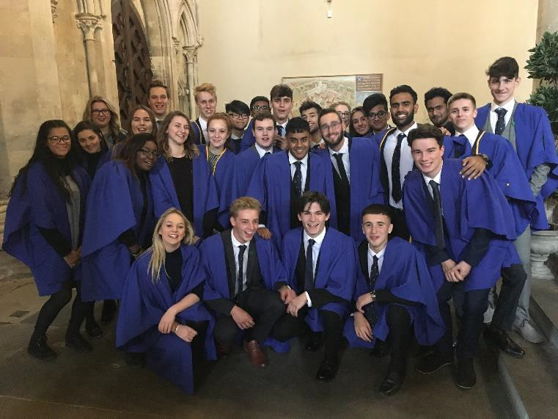
Our aim is to build a learning community of schools to share ‘Educational Excellence for Everyone’ in order to be deemed truly ‘World Class’.

The Trust is keen for member schools to work together to shape the values, ethos and operation of the AAT. The trust board and local governing bodies will be jointly responsible for promoting a culture of respect and high expectations, and ensuring that these values are reflected in the way we operate and the policies we support.

Key principles to define our ethos and culture include:
- Core purpose on achieving the best outcomes for all children served by the Trust
- Shared knowledge and trust to empower everyone built on mutual respect
- All academies in the Trust hold the highest expectations of young people and what they can achieve
- We actively promote equality at all levels in the Trust
- Local governing bodies are in best position to make decisions about their schools - majority of decision making and autonomy rests with individual schools*
- Stakeholder voice is a key ingredient in how we will operate

- Those schools that are in challenging circumstances and join the AAT under a sponsored agreement would have a different balance between centralised control and delegated decision making

To define the values of the trust, we have adopted the mission statement ‘Educational Excellence for Everyone’ .

Vision and Strategy

The vision and strategy for each individual school will be overseen by the local governing body for that school. The AAT will also promote a strategic plan that will provide a common goal for all schools in the Trust to adopt. This will be prepared with input from all partners.
Our starting point for the first 5 years will be:

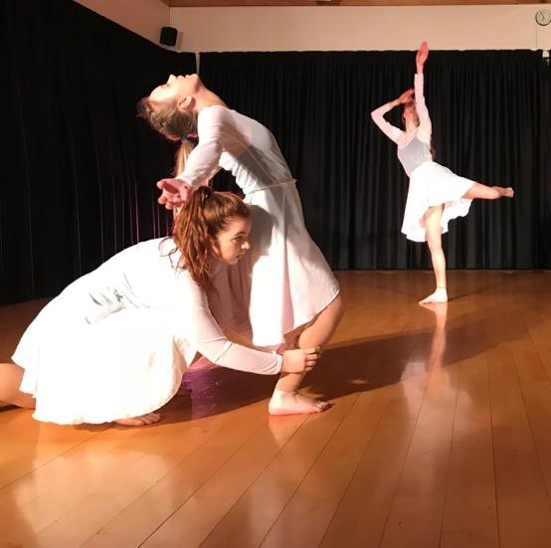
  - To achieve significantly positive outcomes for all young people in our care. The trust aims to secure consistency across the trust so that all families can be confident in receiving a high-quality education irrespective of which school in the trust they attend.
  - To develop as a small to medium sized MAT, with a membership of between 3 – 10 schools. We will manage any growth in a sustainable fashion so that ethos and culture are kept at the forefront of our principles, and that quality and standards come before size.
  - To serve any type of school, and provide a rich environment for progress whether primary or secondary in nature.
  - To serve a geographical area close to St. Albans to facilitate effective collaboration.
  - To provide a powerful organisation that everyone is proud to be part of and is seen as a model of good practice for others.
  - To enjoy working in partnership and learn constantly from each other.

The above will be achieved through delivering a carefully planned strategy for improvement built on knowledge of where we are starting from and understanding of how to move to where we want to get to. This will involve outstanding leadership at all levels and a relentless focus on doing the right things and doing them well.

Performance, Challenge and Support

A critical feature of the AAT will be to ensure strength and depth in quality across the member schools and sufficient capacity to secure improvement. Each school will have strengths and these will be drawn upon to provide support and challenge to others in the trust. There will be the opportunity to link primary with primary, and secondary with secondary within the AAT, but also encourage flexibility and cross-phase working.

Each school will be expected to monitor and challenge its own performance, as usual, but in addition to contribute to the collective knowledge of the trust and provide wider monitoring and challenge as appropriate. The aim is for continuous improvement with different levels of intervention for schools at different stages in their improvement journey operating under an ‘earned autonomy’ approach.

Supporting Academies

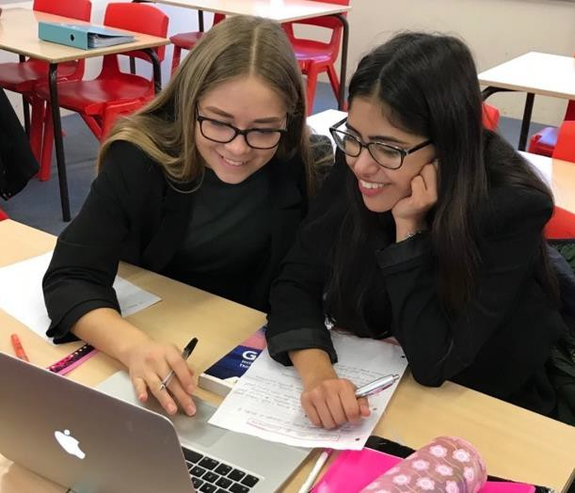
These are our Good and Outstanding schools. They will have an enhanced level of autonomy in making decisions and the freedom to plan and implement their own curriculum. Termly professional meetings with a School Effectiveness Partner will provide support and challenge, and also the opportunity to share expertise with other schools in the AAT. You will be encouraged to develop innovative proposals likely to improve the educational experience and life chances of young people across the AAT. In addition, you are likely to provide many opportunities for staff to develop their expertise by supporting other schools. Training will be available through the AAT and the ATSA for this. We would
hope that all schools in this category move to Outstanding and maintain this category.

Supported Academies

These schools are likely to be currently graded Requires Improvement by Ofsted (or in danger of going into RI). They will receive more regular support from a wider range of external professionals with the objective to move swiftly to Good or Outstanding categories. It is recognised that there will be many staff in these schools who are very capable and can also provide school to school support across the AAT.

Sponsored Academies

These will be schools in RI or Inadequate Ofsted categories, sponsored by the AAT. Most will receive intensive support by experienced professionals across the AAT in order to help move the school to at least Good as quickly as possible. Some of this support may be brokered from other external providers by the AAT.

Staff Development

Staff development is a key element and focus for improvement of standards. Examples of activities include:-
- sharing expertise and focussing significant efforts on the training and development of staff at all levels,
- co-ordinating key CPD events, both within-phase and cross-phase.
- using the Alban Teaching School Alliance to support specific CPD events,
- using latest research to inform our practice and make step changes to our teaching and leadership.

An annual report is produced for trustees to review progress across the year. This will include details of staff development, joint projects and self-evaluation across the Trust.

The governance and leadership of the Trust develops alongside the expansion of the AAT. Key principles for the effective governance and leadership of the Trust includes:
  - Unbiased and neutral governance from the members and the trust board.
  - Governance structures that provide clear delineation of responsibilities (through the Schedule of Delegation) and avoid unnecessary duplication and bureaucracy.
  - Clear and effective channels of communication to allow business to happen
  - Leadership that cherishes all partners and seeks to build teams bringing people together.
  - Opportunities for wide participation in discussion and decision-making processes to ensure strong representation of views are heard.
  - Having people in positions of responsibility who can inspire and support others across the trust.
  - Ensuring that trustees can effectively challenge what is being done

Governance and Leadership structure
Executive Lead Group
(CEO and Headteachers) L
Business Operations Group
(CFO and finance leads)
L
Teaching and Learning and
Personal Development L
(primary and secondary)
Chairs Group
(Chair Trust and CoGs)
L
Sandringham
LGB
G
Members
G
Trust Board
G
Finance and Resources
(including audit)
G
Human Resources
(including Pay)
G
Quality of Education
G
Admissions
G
Ridgeway
LGB
G
Verulam
LGB
G
LGB 4
G
LGB 5
G
LGB 6
G
G—Governance L—Leadership

Members: The Alban Academies Trust is overseen by up to five members. At least three of these members should have no prior connection to any of the trust schools. All members are appointed to provide relevant skills, experience and network opportunities to ensure success and status of the Trust as well as upholding the values and ethos as described.

Trust board: The trust board sets the overall vision, strategy and direction of the Trust. It is composed of between 7-13 people drawn mainly from schools within the AAT but potentially also outside the trust to ensure a broad range of skills for successful operation. All trustees are appointed by considering their experience and skill set in such areas as; Business, Public Sector, Community/Charity, Finance, HR, Legal, School Improvement, Health and Safety, Safeguarding, Education background or the Arts/STEM. As the Trust develops, representation from the various phases of schools across the AAT and the community at large will be appointed, as appropriate.

Resources and Audit committee: This committee is a general requirement in the structure of all Multi Academy Trusts. The AAT board has established a joint Resources and Audit committee with responsibility for monitoring and delivering an effective medium and long-term budget across the Trust, together with other key resource issues as required by the Education Funding Agency. This group comprises trustees and senior staff with relevant expertise in finance and resources, and governors drawn from schools across the AAT. The committee appoints a chair on an annual basis.

Human Resources and Pay committee: The trust
board has established a Human Resources team to take responsibility for overseeing the effective recruitment, retention and deployment of high-quality staff (teaching and non-teaching) across the AAT. It is responsible for ensuring that staffing models meet the expectations of budget allocations from the Resources and Audit committee and that pay decisions are fair and consistent. It oversees equality of opportunity and fair employment practices. This committee comprises of trustees, senior staff and governors with relevant expertise in human resources, drawn from schools across the AAT.

Quality of Education committee: The trust board has established a standards and performance team with responsibility for monitoring and challenging the performance of all schools across the AAT. It reviews and approves the appropriate performance targets to ensure that all schools within the Trust make continual progress and improvement over time. This committee comprises of trustees, senior staff and governors with relevant expertise in standards and performance, drawn from schools across the AAT.

Executive lead group: Much of the operational activity of the AAT is co-ordinated by an operational team composed of headteachers from across the schools, the AAT Chief Finance Officer and AAT Director for School Improvement. This is led by the Chief Executive Officer. This group will be responsible for delivering the AAT’s plan for improvement by ensuring effective communications, decision making and delegation of responsibilities with various leaders within the AAT.

Business operations group: This group co-ordinates the key financial and business operations of schools within the AAT. It will provide support and guidance to finance officers in each school and identify and then implement efficiency savings where appropriate. It will be composed of finance leads at each school and led by the AAT Chief Finance Officer.

Teaching and Learning and Pastoral Developments: These groups share teaching and learning and pastoral development matters from all schools within the AAT and encourage creative and powerful pedagogy and development in all phases. The group advises on CPD programmes and sponsors a variety of development activities. It is composed of key teaching and learning and pastoral leads from the schools and other staff with expertise in
high-order pedagogy. It is led by the AAT Director for School Improvement.

Chairs network: This group will be composed of the CoG from each school in the AAT. The aim will be to strengthen communications at all levels within the organisation to ensure effective discussion and decision making. It will be led by the chair of the trust board (if a CoG) or another CoG as appointed by the group.

Local governing bodies: Each individual academy is governed by its own local governing body. In most cases, the existing governors of the school would transfer to be governors of the new academy. The LGB works on a regular basis with the senior leadership teams to secure outstanding educational provision for the students in their academy. The LGB also works with the trust board to review progress and secure best value. The Schedule of Delegation indicates levels of responsibility between the various levels within the organisation.

DR GEOFFREY COPLAND CBE
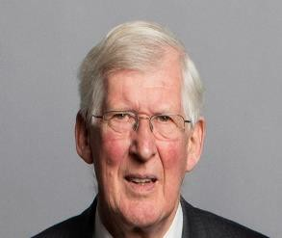
Skillset and experience – A physicist and former Vice- Chancellor and Rector of the University of Westminster from January 1996 until July 2007. Previous positions also held include Vice-President of
Universities and Chair of its England and Northern Ireland Council, Chair of the Universities and Colleges Employers Association, Trustee of Council for Industry and Higher Education, Vice-Chair of London Higher, Board member of the Office of the Independent Adjudicator for Higher Education and other education bodies including TECs. Vice Chair of Harrow Tertiary College and Chair of the HEFCE Sustainable Development in Higher Education Steering Group from 2006 until 2012. A former Trustee of the Helena Kennedy Foundation and former Governor of University of Bedfordshire. Geoffrey was awarded a CBE in the 2007 Queen’s Birthday Honours list for services to higher education

Currently is Chairman of Thomas Wall Trust, International Students House and Learning from Experience Trust, President of ASET, Vice Chair of Trinity Laban Conservatoire of Music and Dance and of Trinity College London.

Following a series of university posts engaged in post- doctoral research, lecturing, and senior management in various universities in London. Since retirement Geoffrey has undertaken a number of consultancy projects for higher education including reviewing the governance structures of two higher education institutions. He has written a report for the Leadership Foundation for Higher Education on issues of good practice and challenges of university governance.

Geoffrey has a career long interest in improving the higher education student experience and access for those who have encountered barriers to conventional academic achievement at pre university level to enable all to achieve their full potential.

REV GRAHAM CLARKE
Skillset and experience – Minister Marshalswick Baptist Free Church St Albans. Trustee of St Albans and Harpenden Education Project.
Community Governor of a Primary School. BA (Hons) Applied Social Science Postgraduate Diploma
Biblical and Theological Studies. Chartered MICPD. Moderator (Chair) of the Central Baptist Association and West Herts YMCA. Regional Director SE England YMCA Project Development, Governance and Management Consultant 1987-97. Director programme development YMCA England – interface with government and funding bodies 1997-2000. Student Minister Eastleigh Baptist Church 2000-2003 responsible for community development and youth work.

Involved in children’s and young people’s work both in schools and in youth work projects. Youth work and voluntary sector governance and management both as a consultant /trainer and Trustee of a number of charities. Youth and community work Liverpool and Leeds 1977- 87.

LADY FLORA LETANKA
Skillset and experience – Executive Director at Teach First. After graduating from Oxford University with a degree in History, Flora taught History and A- Level Politics at Albany School, Enfield (now Oasis Hadley Academy) in one of the first cohorts of the Teach First programme. She then spent four years
advising global banks, law firms and accounting firms on market, brand and growth strategies at Lighthouse Global, a strategy consulting firm. In 2010, Flora joined the Teach First leadership team, developing high-impact alumni programmes, including the well-reputed Teach First Innovation Unit, which has accelerated the growth and impact of over 90 social enterprises, working in the lowest socio-economic areas in England and Wales. She is currently in charge of Teach First's network development
- supporting the spread of knowledge, capacity and expertise through the education system, predominantly via Teach First's networks of 1000 schools and 8000 Teach First alumni. Flora lives in St. Albans and is a Governor of St. Michaels Church of England VA Primary School.

DUNCAN GIBBONS
Skillset and experience – A qualified solicitor who has worked as a senior in house lawyer in a Canadian bank with global management responsibilities.

Previously, Duncan worked as a solicitor in a private practice at a large global law firm, specialising in finance law. He has also been an Army Officer specialising in logistics.

Former Governor of Maple Primary School, Chair of Finance Committee and Chair of Governors in
the final year. Governor of Sandringham School, Chair of Resources, former Chair of CAW.

JIM WRIGHT
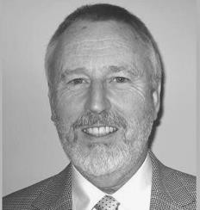
Skillset and experience – Self- employed business consultancy liaising with blue chip companies on strategic thinking, change implementation and leadership development. PhD in Chemistry. Previous roles include leading a research team in the pharmaceutical industry. Global Head
of Human Resources. Parent Governor in a comprehensive school in Surrey.

Jim has lived in St Albans for 20 years. After research in the pharmaceutical industry he transferred into general management. During that period his interests included working closely with secondary and tertiary education to support the development of scientists and to promote awareness of career opportunities in the scientific sector. He has served as non-executive Director on the boards of several not-for-profit organisations. He is currently involved with supporting investment in small businesses in Central and Eastern Europe to promote employment and alleviate poverty and in developing business leaders in these countries. Jim has been a member of the Sandringham Governing Body for the last 7 years where he has chaired the CAW committee and is currently Chair of the HR Committee. Jim is also currently a Governor at Ridgeway Academy.

GREG COMNINOS

Skillset and experience – A qualified Chartered Accountant and has spent his whole career, from trainee to partner, with Deloitte. A current Trustee and Chair of the Citizens Advice St Albans. Greg is also a Community Governor at Sandringham School.

Greg moved office to St Albans when Deloitte established a practice officer there in 1995 and subsequently retired from the firm in 2008. He joined the Sandringham Governing Body in 2013. Through Greg’s role at Citizens Advice St Albans he is able to get involved in wider community issues in St Albans. Greg lives in Berkhamsted and enjoys bridge, travel and, when time permits, retirement.

NICHOLAS DAYMOND
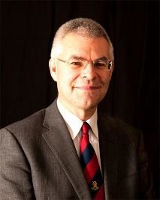
Skillset and experience - Retired Headteacher of Parmiter’s School in Garston 2010-2017 and former Headteacher of Roundwood Park School in Harpenden 2004 – 2010. He has led both schools from “Good” to “Outstanding” through Ofsted inspections.

At different times Nicholas has been Chair of the Links ESC Management Committee in St Albans, Chair of STASSH (St Albans and Harpenden Secondary School Headteachers) and Chair of the St Albans and Harpenden SAPG (Strategic Area Partnership Group 16-19). As an elected member of Schools’ Forum between 2012 and 2016 ensured that money retained at the centre was spent wisely.

Since the beginning of his career in 1985 Nicholas has taught in four different schools in Hertfordshire and so has a good knowledge of the County, its schools and its issues. He is a strong believer in schools working together for the benefit of their students and staff and has always worked hard to improve collaboration. Consequently, Nicholas has taken on a number of additional roles beyond his schools which have given him the opportunity to put this into practice. Parmiter’s currently leads on ITT. Nicholas is a National Leader of Education and trained Pupil Premium reviewer. He has plenty of experience of supporting other schools and was Executive Headteacher of another Hertfordshire school for a term.

ALAN GRAY
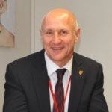
Skillset and experience
– Headteacher of Sandringham School for over 13 years and previously Headteacher at The Hemel Hempstead School for 6 years. Alan is a National Leader of Education and has experience of
working with a number of secondary schools in this capacity to support leadership. Alan has trained and served as an additional OFSTED inspector and chairs Hertfordshire Schools Forum, the Alban Federation (ITT provider) and the Alban Teaching School Alliance. He has previously chaired local and Hertfordshire Headteacher groups. He is a member of the DfE Secondary Headteacher Reference Group, supporting the DfE with guidance on education matters.

Alan has worked closely with governing bodies for over 25 years and has significant experience of school leadership and how to create an outstanding learning environment for all.

RICHARD KENNEDY
Skillset and experience - Richard’s current role with a global gas company requires him to develop and implement strategic programmes in order to deliver on business objectives for revenue, profit and debt. Richard has 14 years experience on school governing bodies. His most recent role has been Chair of Governors at Verulam School.

He is a motivated, hardworking and supportive team member who thrives on building relationships alongside strategy development and implementation.
Richard lives in St Albans with his wife Liz; they have three sons who have all attended school locally. A keen rugby supporter, he also coached with the St Albans based Old Albanian Rugby Club.

LIN KEEN
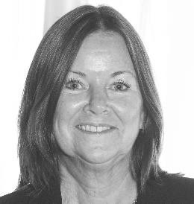
Skillset and experience – Lin is a National Leader of Governance, working with governing bodies in other schools. After graduating from Edinburgh University, Lin started her career in Market Research in Birmingham, moving on to Marketing and eventually relocating to St Albans
to take a position with Cadbury Schweppes. Lin did a variety of freelance work and worked with her husband to build up a Market Research company. She took on responsibility for the finance and company secretarial functions.
Lin first became a parent governor in 1999. Over the years she has been a governor at three different schools in various roles including being a chair at two of these.
Lin is still a governor at Sandringham School and Ridgeway Academy. She is now retired.

NORMAN LEINSTER

Skillset and experience – Norman qualified as a Chartered Accountant in 1991 with the then Touche Ross, and worked in various accountancy roles in the private sector, with firms such as Parity and Citigroup. Norman’s roles focused on financial and management accounting, budgeting, and installing financial systems. Norman then joined the diplomatic service at the Foreign & Commonwealth Office in 2003, and has worked in various policy areas such as Syria and Lebanon, Iraq, the UK Overseas Territories, and also in corporate areas such as IT and Freedom of Information, and Data Protection. He is currently Desk Officer for Anti-Corruption. He has been posted overseas to Kuwait and Pretoria, South Africa.

Norman has lived in St Albans since 1988, attends a local church in St Albans and goes regularly to the National Theatre, Tate Modern, Tate Britain and the Royal Academy
of Arts. He travels widely both with work and for leisure, including many of the Southern Africa countries when he was working in Pretoria. He worked for three years in Germany and France, and speaks both languages.

JEREMY LOUKES
Skillset and experience – Former Headteacher of a Hertfordshire Academy judged outstanding by Ofsted. Jeremy has spent three years as one of Her Majesty’s Inspectors, based in the London region. Jeremy currently has a leadership role in a schools’ company providing school improvement services to primary schools in and beyond Hertfordshire.

Having started his teaching career in London, Jeremy taught across the primary age range, having held teaching and leadership posts in Hertfordshire and London schools. In addition to leading inspections of maintained schools, independent schools and academies, the role
included reviewing local authority arrangements for school improvement and inspecting initial teacher education providers. It also involved carrying out a broad range of quality assurance tasks and leading training for school leaders, Governors and Ofsted Inspectors. He is committed to promoting high standards, including those of disadvantaged students

RICHARD SPRINGALL
Skillset and experience – Richard is an Engineer, who recently retired from his role of UK Technical Director for a Swedish Design & Engineering consultancy. His strong design and engineering skills are complemented by his accomplished leadership skills. His success and passion for improved design and development have seen him invited to lecture at the Royal College of Art, London.
Richard has been a pro-active Community Governor at Verulam School since 2006 and contributed wholeheartedly to supporting and verifying school decisions and policies. Married to Diane, they have three children and have lived in St Albans for 34 years. Richard enjoys sailing, skiing, classic cars and all types of electrical, plumbing and building maintenance.

DEBORAH STRAZZA
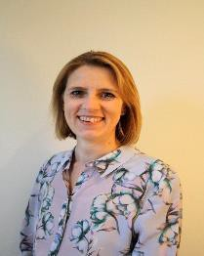
Skillset and experience – Deborah is an experienced HR practioner, with both operational and strategic experience.

Passionate about learning and leadership development she has worked in the retail, automotive and not for profit sectors. For the last 17 years she has been at the John Lewis Partnership where her roles have included Managing Director at Milton Keynes and High Wycombe branches, and most recently the Head of Organisation Effectiveness & Talent Management.

Deborah was a member for the MK Chamber of Commerce Board for three years and now sits on the Young Enterprise Board in Hertfordshire, as well as acting as business advisor & judge on the YE company programme.

She lives in St Albans with her husband and two children. Her daughter attended Marlborough Science Academy , and is now at Nottingham Trent university and her son is a current pupil at Verulam.

PENNY THEI
Skillset and experience – Graduated in 1970 with a degree in Sociology, then in 1971 qualified as a Careers Adviser. In 1998 Penny become a senior lecturer in Career Guidance on the postgraduate diploma at London South Bank University where she taught until she retired in 2014.

Penny was brought up and educated in North West London. As a careers adviser Penny worked in a variety of roles and with a range of client groups including adults. Both Penny’s daughters attended Sandringham School and she then became a Parent Governor. In 2003 when Penny could no longer claim to be a parent in the school, she was co – opted as a Community Governor and served in this capacity until August 2019. Outside of Penny’s Governor role she is a St Albans Green Badge tour guide, sings in the community choir, and volunteers at the museum on various projects.

JIM WRIGHT
Skillset and experience – Self- employed business consultancy liaising with blue chip companies on strategic thinking, change implementation and leadership development. PhD in Chemistry. Previous roles include leading a research team in the pharmaceutical industry. Global Head of Human Resources. Parent Governor in a comprehensive school in Surrey.

Jim has lived in St Albans for 20 years. After research in the pharmaceutical industry he transferred into general management. During that period his interests included working closely with secondary and tertiary education to support the development of scientists and to promote awareness of career opportunities in the scientific sector. He has served as non-executive Director on the boards of several not-for-profit organisations. He is currently involved with supporting investment in small businesses in Central and Eastern Europe to promote employment and alleviate poverty and in developing business leaders in these countries. Jim has been a member of the Sandringham Governing Body for the last 10 years where he has previously chaired the CAW & HR committees. Jim is also currently a Governor at Ridgeway Academy

A key aspect of the Trust is to ensure that available funding and resources are used for the benefit of all, in an open and transparent way. With pressures on funding the AAT will seek opportunities to provide similar or improved services at less cost to schools.

With the exception of the top slice, the actual money available for schools is the same whether or not they are maintained schools or academies. The key difference is that your school’s funding will come directly from the AAT, not via the local authority, and your school will have more freedom to decide how it spends its money. The AAT holds the funding agreement with the DfE and decides how much money to delegate to schools and how much to retain.

The AAT retains approximately between 1-2% of a school’s budget in order to provide essential core services. These core services would include such areas as core HR services, strategic IT, the central AAT team (including CEO, CFO, DSI (Director of School Improvement), and AAT Project Manager), audit etc. Some of these services you will currently pay as a maintained school or single academy so they are not additional costs and will be offset by savings elsewhere. It is envisaged that over time some other services will move into a centralised provision as the AAT gains
experience of working together and identifies keys areas for improvements in efficiency. The development of these central services across the MAT will be driven centrally through discussion and agreement between all parties. Initially any services outside of the core change, will be delivered through service level agreements. Examples of where SLAs may operate include:

IT support
  - Facilities management
  - HR
  - Finance
  - Catering

The approach used will be a growth model, where we learn how to do things better and take time to embed practice that is sustainable and an improvement on the existing offer.
As a Trust we recognise the financial challenges in delivering high quality education within budget constraints. We aim to achieve value for money by working together and making the most of opportunities and economies of scale as part of a larger trust. The Trust will therefore take opportunities to negotiate better deals collaboratively but there may be instances when it is appropriate to retain separate suppliers due to local relationships/preferences.

Central Team

Alan Gray CEO
Julia Shaw CFO
Claire Oakes Director for School Improvement Sarah Warren Project Manager
Tina Crafford Administrator

Our additional professionals

James Heale | School Effectiveness | Flywheel Learning
Susan Poole | Organisation and legal
Jane Ripley | Due Diligence

Process for joining the AAT

The Alban Academies Trust will support any school that wishes to join. Support will include:
- Advice and guidance on academisation process with the DfE
- Advice and guidance on the legal process, including access to solicitors and example documentation
- Advice and guidance on consultation processes including example documentation, timelines and decision making
- Supporting negotiations with the LA over land transfer and other issues
- Advice and guidance on TUPE and staffing arrangements at point of transfer

The Alban Academies Trust will commission a full due diligence of a school wishing to join the trust, and provide the opportunity for the joining school to explore the quality of work within the AAT to ensure it meets the high standards that would be expected.

w w w . a l b a n a c a d e m i e s t r u s t . o r g . u k

